Multicouplers
UHF 300-512 MHz

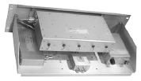  25102-1/P-5 | 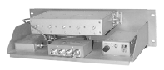  25104-0/P-5 | 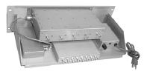  25108-1/P-5

ELECTRICAL SPECIFICATIONS
Model Number | 25102-1/P-5 | 25102-0/P-5 | 25104-1/P-5 | 25104-0/P-5 | 25108-1/P-5
Frequency Band (MHz) | 300-512
# of Channels | 2 |  | 3-4 |  | 5-8
Pass Band | 3-10 MHz
# of Resonators | 5
Rx/Rx Isolation | 23+ dB
System Voltage | 115 VAC
Amplifier Gain | +30
Amplifier Type | Bipolar
Amplifier Noise Figure | 3.0 dB
Amplifier 3rd Order IP | +42 dBm
Amplifier 1 dB Comp | +21 dBm
Amplifier Bias Voltage | 13.6 VDC
Amplifier Current Draw | 200 mA
System NF (typ.) | 5.0 dB
Nominal Inpedance | 50 Ω
Max. VSWR @ Resonance | 1.25:1
Temperature Range | - 22 to +140� F  -30 to +60� C
MECHANICAL SPECIFICATIONS
Dim (WxD) Inches  Metric | 5 1/4 x 19 x 10  134 x 483 x 254
Connectors | N / BNC | N / N | N / BNC | N / N | N / BNC
Ship Weight: lbs / kg. | 12 / 5.4

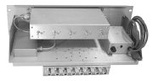  25108-0/P-5 | 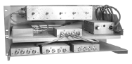  25112-1/P-5 | 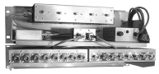  25116-0/P-5

ELECTRICAL SPECIFICATIONS
Model Number | 25108-0/P-5 | 25112-1/P-5 | 25112-0/P-5 | 25116-1/P-5 | 25116-0/P-5
Frequency Band (MHz) | 300-512
# of Channels | 5-8 | 9-12 |  | 13-16
Pass Band | 3-10 MHz
# of Resonators | 5
Rx/Rx Isolation | 23+ dB
System Voltage | 115 VAC
Amplifier Gain | +30 dB
Amplifier Type | Bipolar
Amplifier Noise Figure | 3.0 dB
Amplifier 3rd Order IP | +42 dBm
Amplifier 1 dB Comp | +21 dBm
Amplifier Bias Voltage | 13.6 VDC
Amplifier Current Draw | 200 mA
System NF (typ.) | 5.0 dB
Nominal Inpedance | 50 Ω
Max. VSWR @ Resonance | 1.25:1
Temperature Range | - 22 to +140� F  -30 to +60� C
MECHANICAL SPECIFICATIONS
Dim (WxD) Inches  Metric | 5 1/4 x 19 x 10  134 x 483 x 254 | 8 3/4 x 19 x 10  223 x 483 x 254
Connectors | N / N | N / BNC | N / N | N / BNC | N / N
Ship Weight: lbs / kg. | 12 / 5.5 | 15 / 6.9 |  | 17 / 7.8

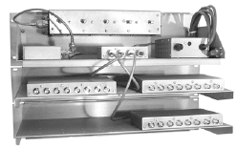  25124-1/P-5 | 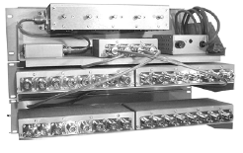  25132-0/P-5

ELECTRICAL SPECIFICATIONS
Model Number | 25124-1/P-5 | 25124-0/P-5 | 25132-1/P-5 | 25132-0/P-5
Frequency Band (MHz) | 300-512
# of Channels | 17-24 |  | 25-32
Pass Band | 3-10 MHz
# of Resonators | 5
Rx/Rx Isolation | 23+ dB
System Voltage | 115 VAC
Amplifier Gain | +30 dB
Amplifier Type | Bipolar
Amplifier Noise Figure | 3.0 dB
Amplifier 3rd Order IP | +42 dBm
Amplifier 1 dB Comp | +21 dBm
Amplifier Bias Voltage | 13.6 VDC
Amplifier Current Draw | 200 mA
System NF (typ.) | 5.0 dB
Nominal Inpedance | 50 Ω
Max. VSWR @ Resonance | 1.25:1
Temperature Range | - 22 to +140� F  -30 to +60� C
MECHANICAL SPECIFICATIONS
Dim (WxD) Inches  Metric | 12 1/4 x 19 x 10  312 x 483 x 254
Connectors: Input  Output | N  BNC | N  N | N  BNC | N  N
Ship Weight: lbs / kg. | 21 / 9.6 |  | 23 / 10.5

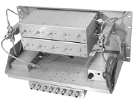  25108-0/DP-5 | 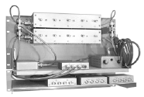  25112-1/DP-5 | 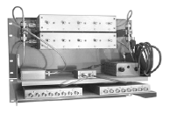  25116-1/DP-5

ELECTRICAL SPECIFICATIONS
Model Number | 25108-1/DP-5 | 25108-0/DP-5 | 25112-1/DP-5 | 25112-0/DP-5 | 25116-1/DP-5
Frequency Band (MHz) | 300-512
# of Channels | 5-8 | 9-12 |  | 13-16
Pass Band | 3-4 MHz
# of Resonators | 5
Rx/Rx Isolation | 23+ dB
System Voltage | 115 VAC
Amplifier Gain | +30 dB
Amplifier Type | Bipolar
Amplifier Noise Figure | 3.0 dB
Amplifier 3rd Order IP | +42 dBm
Amplifier 1 dB Comp | +21 dBm
Amplifier Bias Voltage | 13.6 VDC
Amplifier Current Draw | 200 mA
System NF (typ.) | 5.0 dB
Nominal Inpedance | 50 Ω
Max. VSWR @ Resonance | 1.25:1
Temperature Range | - 22 to +140� F  -30 to +60� C
MECHANICAL SPECIFICATIONS
Dim (WxD) Inches  Metric | 8 3/4 x 19 x 10  223 x 483 x 254 |  | 12 1/4 x 19 x 10  312 x 483 x 254
Connectors: Input / Output | N / BNCN | N / N | N / BNC | N / N | N / BNC
Ship Weight: lbs / kg. | 22 / 10.0 |  | 24 / 10.9 |  | 26 / 11.8

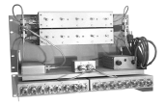  25116-0/DP-5 | 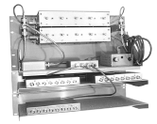  25124-1/DP-5 | 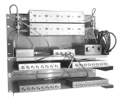  25132-1/DP-5

ELECTRICAL SPECIFICATIONS
Model Number | 25116-0/DP-5 | 25124-1/DP-5 | 25124-0/DP-5 | 25132-1/DP-5 | 25132-0/DP-5
Frequency Band (MHz) | 300-512
# of Channels | 5-8 | 17-24 |  | 25-32
Pass Band | 3-4 MHz
# of Resonators | 5
Rx/Rx Isolation | 23+ dB
System Voltage | 115 VAC
Amplifier Gain | +30 dB
Amplifier Type | Bipolar
Amplifier Noise Figure | 3.0 dB
Amplifier 3rd Order IP | +42 dBm
Amplifier 1 dB Comp | +21 dBm
Amplifier Bias Voltage | 13.6 VDC
Amplifier Current Draw | 200 mA
System NF (typ.) | 5.0 dB
Nominal Inpedance | 50 Ω
Max. VSWR @ Resonance | 1.25:1
Temperature Range | - 22 to +140� F  -30 to +60� C
MECHANICAL SPECIFICATIONS
Dim (WxD) Inches  Metric | 12 1/4 x 19 x 10  312 x 483 x 254 |  | 15 3/4 x 19 x 10  312 x 483 x 254
Connectors: Input / Output | N / N | N / BNC | N / N | N / BNC | N / N
Ship Weight: lbs / kg. | 26 / 11.8 |  | 28 / 12.8 |  | 30 / 13.7

